**Nov 2017 SL P1**

**Section A**

1. Identify **two** essential features of a computer language. [2]
2. Two fundamental operations of a computer are add and retrieve. State another **two**   
   fundamental operations. [2]
3. In the context of a networked world, state the role of
4. a client. [1]
5. a server. [1]
6. Identify **one** method of inputting data that can improve the accessibility of a computer

system for some users. [1]

1. Copy and complete the following truth table. [3]

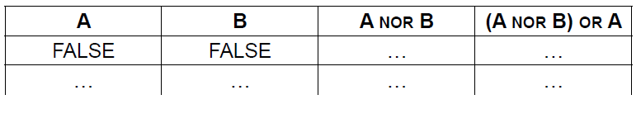

1. Construct a logic diagram for the Boolean expression

NOT A OR B AND C. [3]

1. 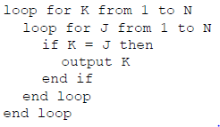Consider the following algorithm, where N is a positive integer

1. Determine the number of times the comparison K = J will be performed. [1]
2. Determine the number of times the statement output K will be executed. [1]
3. Construct the algorithm which performs the same task using a single while loop,

instead of nested for loops. [4]

1. The machine instruction cycle is the process by which a program instruction is fetched,

decoded, executed and the results are stored.

1. State where all instructions and data are stored. [1]
2. Outline the role of the data bus and address bus in this process. [2]
3. Define the term bit. [1]
4. Outline what is meant by beta testing. [2]

**Section B**

1. An application package used in an office includes a word processor. A secretary uses the

word processor to create a text file.

1. Describe how a spellchecker checks whether a word in a text file is correctly spelt

or not. [2]

The text file is automatically saved at regular periods while being edited.

1. State **one** advantage of this feature. [1]
2. Identify **two** additional features of a word processing package that could be useful for   
   this office. [2]
3. Outline the purpose of **one** application software package other than a word processing

package that could be used in this office. [2]

All files created in this office contain information important to the business.

1. Outline the security measures that should be taken to prevent data loss. [4]

The office manager decides to buy and install new software and hardware.

1. Outline **one** problem that may arise from the installation of new hardware and software

in the office. [2]

The changeover to the new system can be achieved by either direct changeover or  
 phased conversion.

1. Compare direct changeover and phased conversion. [4]

1. A wireless local area network (WLAN) is used to extend access to a school’s wired

local area network.

1. Identify **one** hardware component of the WLAN, other than computers. [1]

The advantages of this WLAN are user-mobility and economical access points.

1. Outline **two** disadvantages of this WLAN. [4]

1. Identify **three** ways in which the network administrator can reduce the risk of   
   unauthorized access to confidential data. [3]

The concept of packet data transmission is used within this network. Figure 1 shows the   
 simplified structure of a data packet.

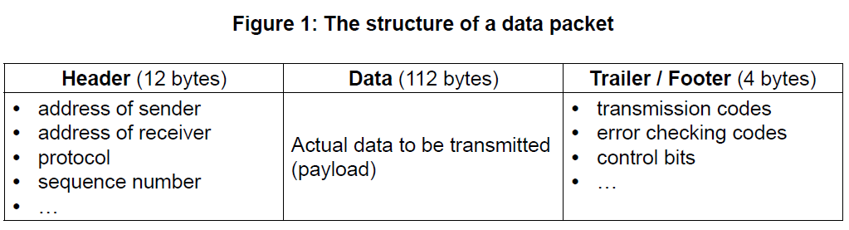

1. Define the term protocol. [1]
2. With reference to **Figure 1**, explain how data is transferred by packet switching. [6]
3. A character array S holds the word “PSEUDOCODE”.



1. State the index of character “U” in the array S.
2. Consider the following algorithm. The function len() returns the number of characters

in an array (for example, len(S) is 10).

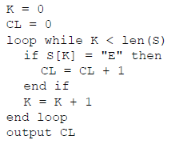

For this algorithm, complete the following trace table. [4]

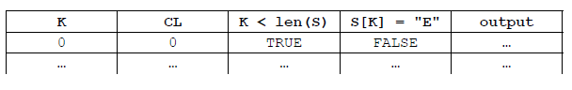

A simple method of encoding a message is to use substitutions to produce a cryptogram.

Given a positive integer N and the array UPCASELETTERS containing letters in alphabetical

order, a new array SUBSTITUTE is created by shifting the entire contents of UPCASELETTERS

to the left, N times. As an element moves off the left of the array, it moves back into the right

side of the array.

For example, given the array UPCASELETTERS:



When N = 5 the array SUBSTITUTE will be:



1. Construct an algorithm which creates the array SUBSTITUTE. You may assume that a

positive integer N and array UPCASELETTERS are given. [5]

This encoding method produces a cryptogram of a sentence by replacing each uppercase  
letter of the sentence with its substitute. Other characters in the sentence are not changed.

For example, using the arrays shown on page 6:

Input (sentence): ARS LONGA, VITA BREVIS.

Output (cryptogram): FWX QTSLF, ANYF GWJANX.

The following algorithm fragment inputs the characters, one by one, from the input sentence,  
and outputs its cryptogram using the method encode().

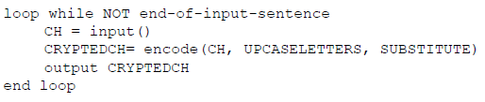



The method encode() accepts a character CH and two arrays UPCASELETTERS and

SUBSTITUTE, as defined above, and returns the corresponding character CRYPTEDCH of the

character CH.

1. Explain the steps to construct an algorithm for the method encode(). [5]